SR UNIVERSITY

AI CODING

NAME:SONNAILA ONKAR

ENROLLMENT NO: 2403A54108

BATCH NO:04

ASSIGNMENT NO:4.2

Task Description#1  
• Zero-shot: Prompt AI with only the instruction — Write a Python function to  
generate the Fibonacci sequence up to n terms

Prompt:



Code:

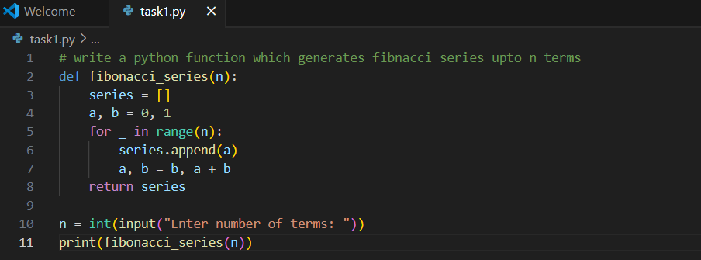

Output:

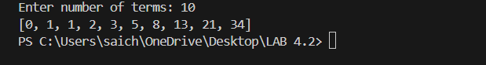

Explanation:

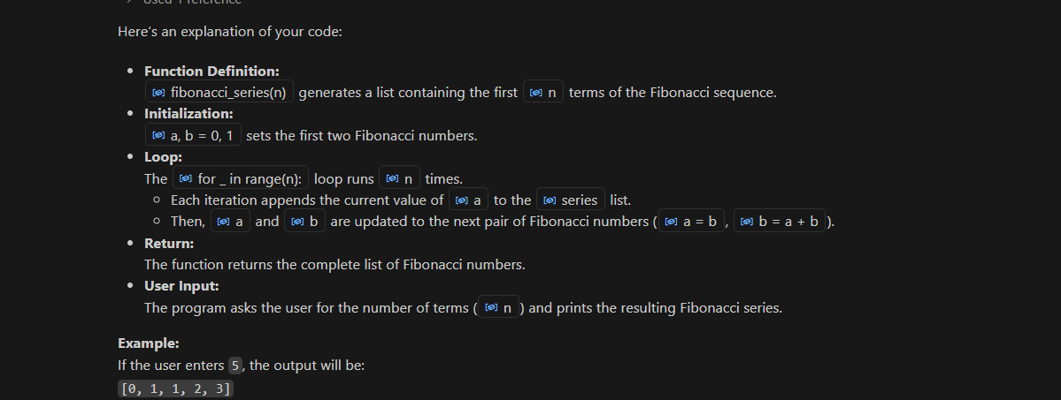

Task Description#2  
• One-shot: Provide one example: Input: 100, Output: 37.78 to help AI generate a  
function that converts Fahrenheit to Celsius.

Prompt:

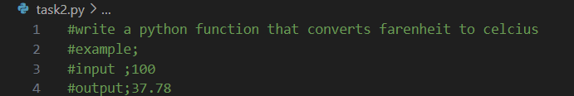

Code:

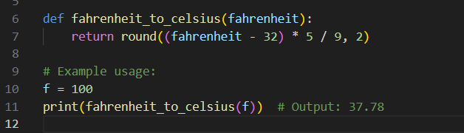

Output:

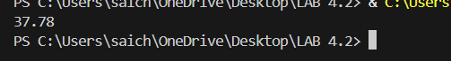

Explanation:

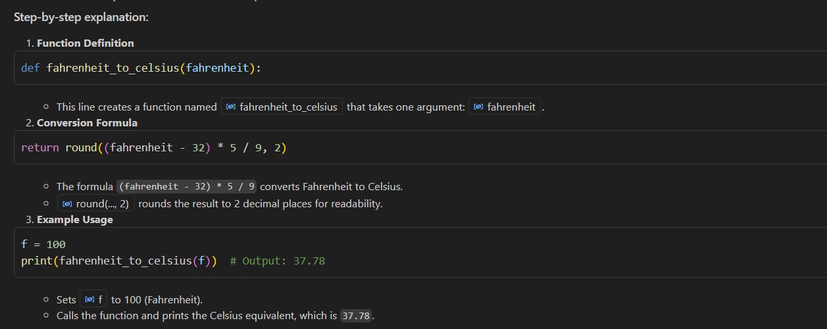

Task Description#3  
• Few-shot: Give 2–3 examples to create a function that extracts the domain name from  
an email address

Prompt:



Code:

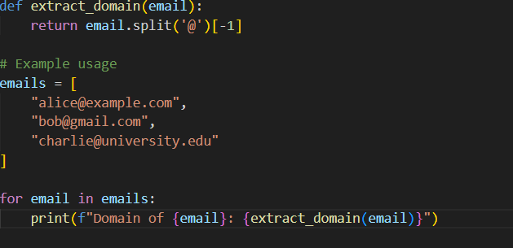

Output:

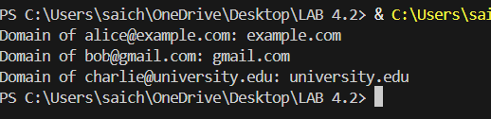

Explanation:

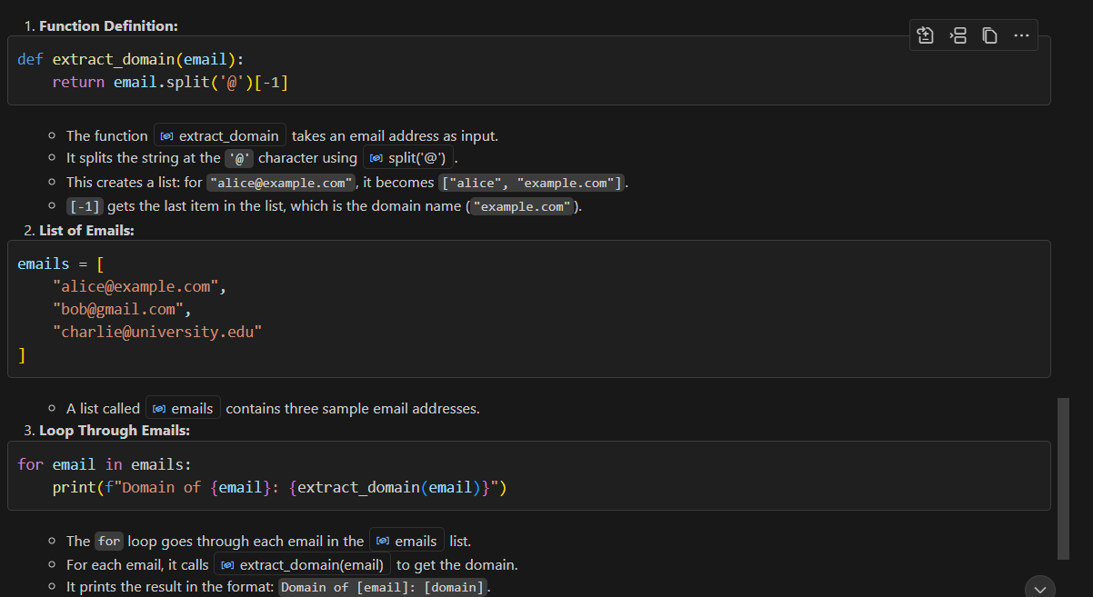

Task Description#4  
• Compare zero-shot vs few-shot prompting for generating a function that checks  
whether a word is a palindrome, ignoring punctuation and case.  
Expected Output#4  
• Output comparison + student explanation on how examples helped the model

Prompt:

Code:

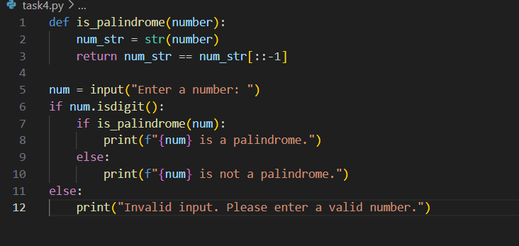

Output:

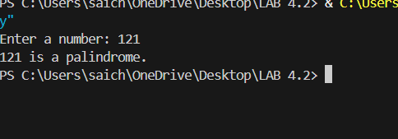

Explanation:

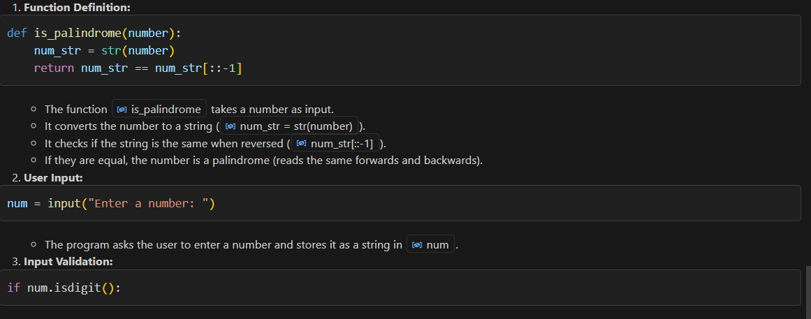

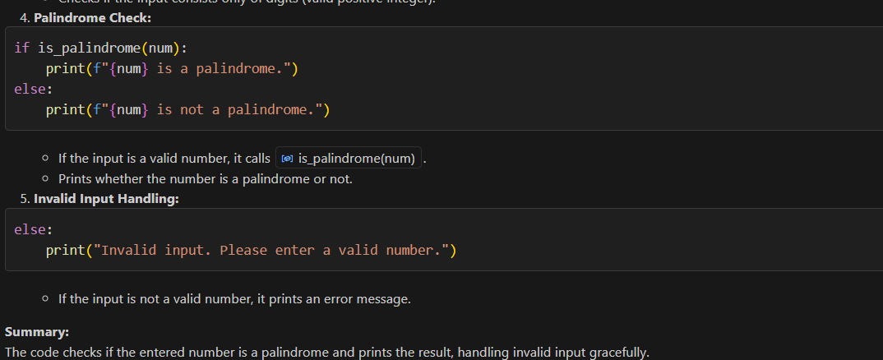

Task Description#5  
• Use few-shot prompting with 3 sample inputs to generate a function that determines  
the maximum of three numbers without using the built-in max() function.  
Expected Output#5  
• A function that handles all cases with correct logic based on example patterns

Prompt:



Code:

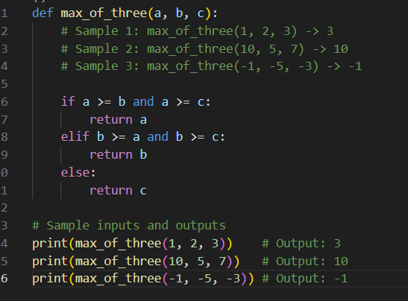

Output:

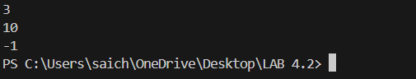

Explanation:

